28-08-2026

EXPERIMENT 33 – NUMBER OF VOWELS

AIM
To write a Prolog program to find the number of vowels present in a given word.

ALGORITHM
- Start the program.
- Define the vowels a, e, i, o, u.
- Read the characters of the given word.
- Check each character and increase the count if it is a vowel.
- Display the total number of vowels.

PROGRAM
vowel(a).
vowel(e).
vowel(i).
vowel(o).
vowel(u).

count_vowels([], 0).

count_vowels([H|T], Count) :-
vowel(H),
count_vowels(T, C),
Count is C + 1.

count_vowels([H|T], Count) :-
\+ vowel(H),
count_vowels(T, Count).

OUTPUT

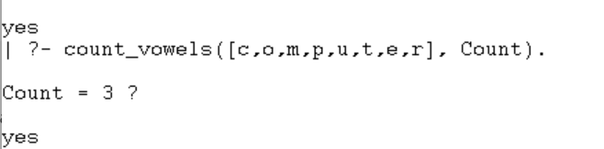

RESULT
Thus, the Prolog program was successfully executed to count the number of vowels in a given word.

